**Washtenaw County 4-H**

**Cat Information and Showmanship Guide**



# Types of cats

## Feral Cats



Feral cats are domestic cats that have been born to other feral cats or stray cats, usually in an outdoor setting, and have limited contact with humans. Because of the limited contact with humans, they are not able to be handled and remain in an outdoor setting and remain unsocialized. There are current efforts to trap, sterilize (spay or neuter) and release these cats back into the outdoor environment. There are many people in the community that care for these cats by offering food and protection from the elements and watch over the colonies.

These cats may also live in and around farms to help with rodent populations. Many farmers and barn owners keep these cats around to reduce the number of varmints that may consume or contaminate their grain, hay and other resources.

In the urban environment, a healthy colony helps keep other cats from inhabiting the territory as well as controlling the rodent population.

These cats do typically have a shorter life span than in their indoor counterparts. They face the dangers of weather, traffic, inter-colony aggression (cat fights), and communicable diseases such as feline leukemia (FeLV) and feline immunodeficiency virus (FIV). On average, these cats only have a life span of 8 years maximum. With exceptional care from a well-seasoned colony caregiver some may live longer lives.

Because of their unsocialized nature, these cats tend to be seen more around dusk, dawn and the overnight hours than during the day. In a well-trained colony they may become accustom to regular feeding times and be more likely to come out to eat when the caretaker is feeding.

## Stray Cats

These are cats that have either been lost or may have been released by their owners. They have been socialized and used to human contact at some point during their life. While feral cats tend to live in colonies with other feral cats, stray cats are usually seen alone and are more likely to be out during the daytime hours. They will typically vocalize and “communicate” with humans, while feral cats will keep their distance.

In many cases these cats can be contained and taken to a rescue group or humane society and adopted by a new family. These cats should also be checked for an implanted microchip in case they had been lost by a previous family.

## Domestic Cats

These are the most familiar cats to most humans. These are the cats that live in our houses, sleep in our bed and warm our hearts. Sometimes these cats have been born to outside feral queens and rescued by individuals in an effort to reduce feral populations. Socialization at a young age is the most important part to break the cycle of being feral.

Domestic cats have a desire to be with humans and see them as a positive source of food, warmth and protection. They communicate with their humans with chirps, purrs and meows. They make excellent companions.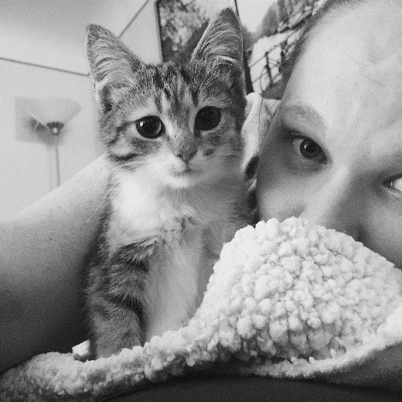

These cats do sometimes go outside to explore their environment and can be mistaken for stray cats. It is recommended to keep some type of identification on your cat if it is going to making trips outside. You also need to worry about the same communicable diseases that feral cats may contract if they are going to venture outside unsupervised. There are options to keep your cat happy and visit the outdoors safely, like a cat stroller and harness with leash.

# Husbandry

## Diet

Felines are obligate carnivores and require meat protein in their diet to keep them healthy. Most commercially made diets are balanced and come in different forms. The dry kibbles are low in moisture and high in carbohydrate and calories. Wet (canned) food is high in moisture and moderate in carbohydrate and calories. Talk with your veterinarian abo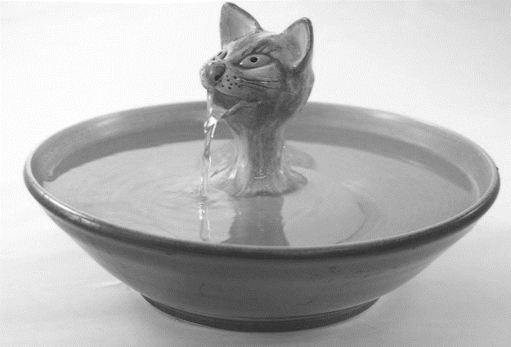ut which diet would best suit your cat’s needs.

## Water

Most cats prefer to have fresh moving water. This is why many cats like you to turn the tap on to get a drink or prefer a pet fountain. If using a fountain be sure to clean and use filtered water per the manufacturer’s recommendations. Many cats do not take in enough water, especially when fed a primarily dry food diet. Encouraging water intake will help your cat stay well hydrated and healthier, especially in later life.

## Litter

Cats have an innate mechanism to cover their eliminations. This includes both urine and stool. It’s important to give your cat a comfortable place to do this and the most common way is the use of a litter box. There are many litter substrates commercially available. Make sure to carefully consider and be consistent with the substrate being used as some cats can be sensitive to texture and scents. Litter boxes should be scooped and cleaned regularly. A litter box should never go more than 24 hours without being maintained. It is also necessary to provide an adequate number of litter boxes; the general rule of thumb is one box per cat in the household plus an additional box (example: 2 cats in house = 3 litter boxes). Some cats prefer boxes larger than standard size. A low-sided storage box or mixing container filled with litter can easily be used.

## Environment

Cats need to have enrichment to keep them happy and healthy. It increases their activity level, provides mental stimulation and helps prevent behavioral problems. Vertical space is highly desirable for cats. Provide a cat tree, perch or shelf to increase the space available in the environment. Scratching is a natural behavior and cats should have a variety of acceptable scratching materials available to them (for example wood, rope or fabric material placed either vertically or horizontally). Keep routines at home predictable but not boring. Provide small changes that offer something new from time to time. Rotate toys to keep them exciting. Encourage cats to frequently play stalk and catch games. Domestic cats especially love to play interactive games with humans. Feeding can become interactive if owners throw kibbles for the cat to chase, provide puzzle feeders or hide food in new locations for the cat to find. Introduce any large changes to a cat's environment gradually (for example starting with a single room when moving to a new home). Use positive reinforcement, not punishment when training your cat.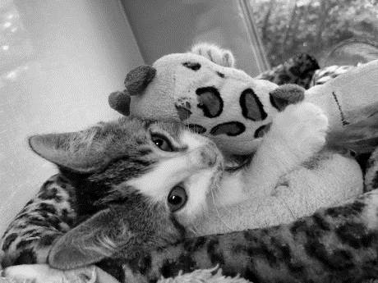

## Grooming

While most cats care for themselves when it comes to grooming, they may need some help from you. Some grooming items you might want to have on hand for your cat include nail trimmers and comb. Long haired cats are especially prone to matting and it may be necessary to have regular grooming with a professional to limit the discomfort caused from matting. Most cats require nail trims every 4 to 6 weeks (unless outdoor/barn cats). Getting your cat used to combing can be beneficial for an aging kitty that may not groom as well when older. Because cats do groom themselves there is typically no reason to bathe your cat unless it has gotten something on its coat that is undesirable and requires additional washing.

# 

# Vaccinations

## Rabies Vaccination

This is a core vaccine for all cats and many other animals. It protects from the fatal disease caused by the rabies virus. This is not only a protectant for your cat but also the humans interacting with him/her. This vaccine is given to cats at the age of 16 weeks (4 months), which is why it’s important to choose a cat for showing that fits this age requirement.



## Feline Rhinotracheitis, Calicivirus, and Panleukopenia (Distemper, FVRCP) Vaccination

This is also a core vaccine for all indoor and outdoor cats. It contains the most common upper respiratory viruses that are contagious among cats. All of the viruses that it protects against can cause other complications in an otherwise healthy cat. For cats that have a higher risk of contracting these diseases it may be recommended to give this vaccine more frequently.

## Feline Leukemia Vaccination

This is not considered a core vaccine for cats with a low risk of exposure. It is, however, recommended for cats that may have exposure to cats of unknown vaccination status (for instance cats that go outdoors) or live with cats carrying the feline leukemia virus.

# Parasites & Prevention

## Intestinal Parasites

Intestinal parasites are common for the outdoor cat. These parasites can cause a menagerie of complications from insignificant to complicated. Most commonly they are worms or protozoans (single celled organisms) causing diarrhea which can lead to weight loss and dehydration. In young or ill cats, they can cause failure to thrive. The most common intestinal parasites include roundworms, tapeworms, coccidia and giardia. These can be contracted in several ways including ingestion of contaminated fecal mater while grooming, ingestion of other animals (such as mice) that are infected with them or from consuming contaminated water. A fecal sample should be completed periodically to check for intestinal parasites, especially for outdoor cats.

## Ectoparasites

Ectoparasites include fleas, mites and ticks. Most commonly in cats we see fleas, especially for those that go outside, although there is an increasing amount of ticks every year. Fleas can cause numerous issues including the transmission of tapeworms and allergic reaction to the bites (Flea Allergic Dermatitis or FAD). Ticks are of concern because of the transmission of other serious diseases such as Lyme Disease. Mites, while not common, can cause skin lesions and discomfort. Ear mites are common in young cats when found outside. These mites invade the ear canals and cause large amounts of “coffee ground” debris that can cause further complications. Combing for fleas and ticks is typically used for diagnosis and skin scrapings or skin impressions are used for diagnosing mites. If ear mites are suspected, your veterinarian may recommend an ear swab to look for mites under the microscope.

## Heartworm

The prevalence of heartworm in cats has been increasing just as it has in dogs. Heartworms are transmitted by mosquitos and adult worms are actually found in the heart. Heartworm larvae can be found circulating in the blood. Cats are not the natural host of heartworm, so unlike dogs which can have hundreds of worms causing heart problems, cats can have no adult heartworms to only 1-5 adult heartworms. Even immature heartworm can cause serious respiratory disease in cats. The most common sign of heartworm in cats is “sudden death”. They don’t always show signs or symptoms commonly associated with heartworm infection. Testing for the parasite is done by blood sample but can sometimes be difficult to confirm because of the low numbers of adult worms that cats carry. The medication used to treat heartworm infection in dogs can't be used in cats, so monthly heartworm preventative is the only way to protect cats from this disease.

## Parasite Prevention

While there are no all-in-one preventatives, you can provide protection for many parasites with one to two preventatives per month. Popular preventatives for cats are typically topically applied to the skin at the back of neck. These can prevent things such as heartworm, fleas, ear mites, and roundworms. Most are applied monthly and come highly recommended for all cats, even indoor only cats.

# Common Communicable Diseases

## Feline Herpes (Rhinotracheitis)

This is a common disease process that many kittens suffer from. It causes severe eye and nose discharge that can become serious enough to cause loss of vision. It can become a full upper respiratory infection and include difficulty breathing when it becomes severe. Because it is caused by a virus, antibiotics do not treat the viral infection but rather prevent any secondary bacterial infections while the immune system works to fight off the viral infection. This virus will remain within the body of the cat for its entire life and can, in times of stress and anxiety, flare up and cause similar symptoms. Cats can become infected when they are born to a queen that may be a carrier for the virus or when they come in contact with other cats or items that have been exposed. A vaccine is available to help prevent and minimize the severity of this viral infection (FVRCP or Distemper vaccine).

## Feline Immunodeficiency Virus (FIV)

Because this disease attacks the immune system of cats (like HIV in humans) it makes them more prone to secondary infections so they typically require more aggressive treatment should they become ill. This disease is typically transmitted from deep bite wounds and is most prevalent in outdoor un-sterilized cats (unneutered males). Many of these cats are able to live peacefully with other FIV negative cats without transmission and live long healthy lives. There is no reliable vaccination for this virus. The virus is commonly tested for with a SNAP test and results are available immediately.

## Feline Leukemia Virus (FeLV)

Unlike in humans, this form of leukemia is caused by a virus. Like FIV, this virus attacks the immune system but more aggressively. It is also much easier to transmit this virus via nasal secretions and other bodily discharge. It does not require the deep bite wounds that FIV does to be transmitted. There is a vaccination for prevention of this disease for those that are at high risk. This virus is also commonly tested for with a SNAP test and results are available immediately.

# Common Non-Communicable Diseases

## Urinary Concerns

One of the most common concerns cats are presented to the veterinary clinic for is inappropriate urination. This means most of the time that a cat is urinating outside of the litter box and has chosen another place in the home like a bed, rug, table, etc. to urinate. Usually this is a signal that something is wrong either medically or behaviorally. Cats may also make frequent trips to the litter box, urinate only small amounts or vocalize while straining to urinate. Urinary infections are more common in older female cats and will be treated with antibiotics. Urinary crystals can also cause problems. There are many possible underlying causes of urinary crystals and they can occur in both male and females, but they are of most concern in males. These crystals can cause a urinary blockage in males that will not allow the cat to urinate which can become a medical emergency very quickly. Treatment of urinary crystals usually involves a diet change and sometimes surgery if a blockage or stones are present. Cats can also present with cystitis, or bladder wall inflammation, and usually have bloody urine with no obvious cause. There are many treatment options for these cats and it is best to consult with your veterinarian if any urinary concerns present themselves. Behavioral urinary issues can also arise. Good litterbox hygiene and monitoring by the owner is of utmost importance. Diagnosis of urinary concerns are are often confirmed with a complete urinalysis, blood work, and radiographs (x-rays).

## Renal Dysfunction

As cats age, it is not uncommon to see some renal (kidney) dysfunction. Sometimes, renal disease is not detected until the late stages where palliative treatment is the best option. When detected early, diet changes and supportive treatment can begin to help slow the progression. There is no reversal of kidney disease once it begins, only supportive treatment to slow it. These cats tend to lose weight, become less interested in food and increase their water intake. Diagnosis of renal dysfunction is usually obtained by blood work and urinalysis.

## Hyperthyroidism

This disease can have onset as early as 8-10 years of age. These cats usually present extremely hungry and even though they eat everything offered to them they lose weight. This disease can also cause complications with other organ systems including the heart if left untreated. Treatment of this disease includes daily medication for the rest of the cat’s life, thyroidectomy (removal of the thyroid gland), or radioactive iodine (I-131) administration.

## Diabetes

Just like in humans, this disease can attack a cat at any age, although it is typically seen in the middle-aged cat. The symptoms are similar to those in humans including always being hungry, weight loss, and increased water intake and urine output. Cats can actually go into remission from diabetes, so it is very important to monitor for signs of hypoglycemia (low blood sugar causing weakness, low energy, disorientation, etc.) when treating for diabetes. Diagnosis is made by blood work and urinalysis. Treatment is daily insulin injections and often diet change.

# Fitting

## Selecting a cat for show

It is important to choose a well socialized cat. Spend time with your cat and travel with your cat prior to showing. Some cats can become stressed and anxious when traveling. Because the judge may be interacting with your cat, allowing others to touch and work your cat is also encouraged. Since most cats adopted from shelters and rescues do not have specific breeds, it is not important to know the specific linage unless the cat was purchased from a breeder. Most cats would be classified as domestic shorthair, domestic medium hair or domestic longhair. Select a cat that is 4 months or older and up to date on vaccinations, testing and parasite prevention.

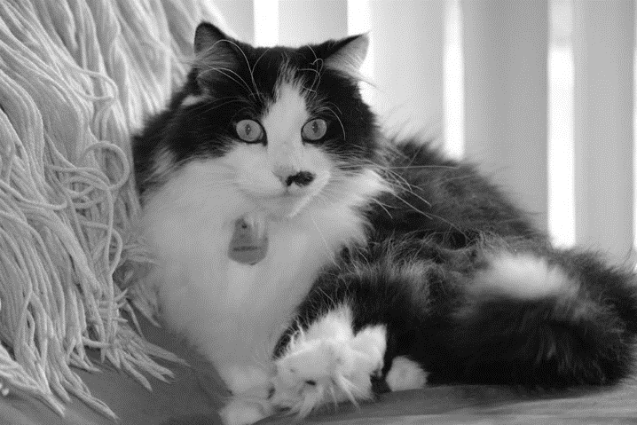

## Preparing for show

It is helpful to trim the nails of your cat the day prior to the show. It is not recommended to do it the same day as this can sometimes cause stress in your cat. You may also want to comb your cat to make sure its coat is in the best condition. Have a well-ventilated carrier for travel prepped and ready to go by acclimating your cat to the carrier. Go through the routine of showing and practice this with your cat. Do a brief exam on your cat in the weeks leading up to the show to ensure your cat is parasite free. A visit to your veterinarian may also be needed. All entries must be current on vaccines for Feline Rhinotracheitis, Calicivirus, Panleukopenia (FVRCP) and Rabies. All entries must have history of a negative FIV/FeLV test. Leukemia Vaccine and a negative fecal sample within 6 months of the show are required for any entries allowed outdoors. You should also acclimate your cat to a harness and leash to help with securing your cat while in the judging area. This will ensure the safety of your cat.

# Presentation & Examination

## Appearance and conduct

It is important for the exhibitor to appear presentable. It is recommended to wear closed toe shoes to prevent foot injury in the judging area. You may wear comfortable and presentable clothing such as dress slacks and polo shirt. If preferable, you may wear a white lab coat during presentation to the judge. Be respectful of others and cats. Be quiet but attentive during the judging process. Come forward to the judging area only when called to help keep cats calm.

## Safety carry and presentation

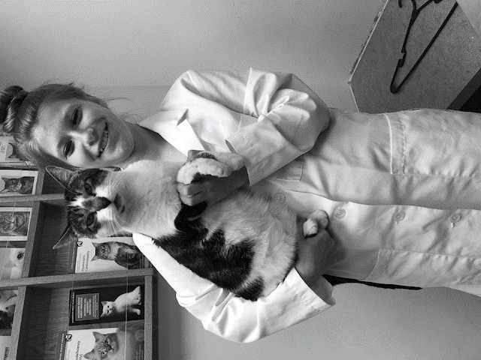You should be able to demonstrate appropriate carrying and restraint of your cat. Your cat should always be wearing a harness and leash for presentation. When picking up your cat for placement on the judging table it should be presented in the “safety carry” position. You can achieve this position by grasping the cat’s forelegs between your thumb and fingers, with at least one finger between the cat’s legs. Support the cat’s chest in the palm of your hand. Then, you may either tuck the cat’s rump and rear legs under your elbow against your body or riding on your hip, or you may hold the cat’s rear legs in the same manner as the cat’s forelegs.

## 

## Examination for show

** The cat in the following images is not wearing a harness and leash. Please be sure your cat is comfortable in a harness and leash as they will need to keep this on during the entire judging**

Carry your cat forward in the safety position and place your cat on the table facing the judge in the sitting (or laying) position with its tail wrapped to the side. Wait for the judge to indicate that you may begin your examination. For the examination portion of the judging, you should be able to present each individual body system, including eyes, ears, nose, mouth/teeth, coat, and paws/claws. Take a nose to tail approach to your examination. See pictures below for examples of each step.

### Step 1: Shape of head

Show the shape of your cat’s head first, with your hands, and verbally give the description (round, rectangular, triangular).

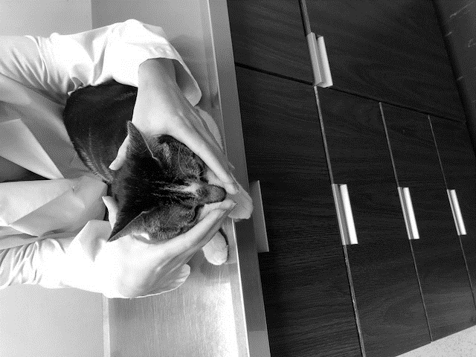

9.3.1. Shape of head

### Step 2: Shape and length of body

Show the shape of your cat’s body by standing your cat up and showing the side of your cat to the judge. Place both hands under the cat, one behind the front legs and one in front the cats hind legs, and stretch the cat to show the full length and shape. Verbally describe what you are showing including the body condition of the cat.

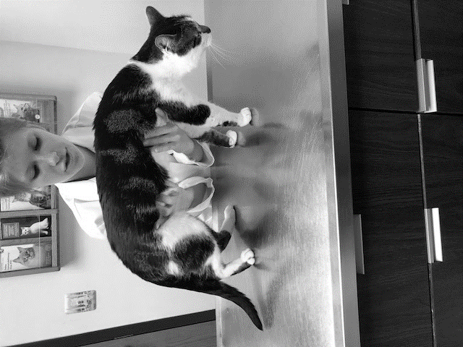

9.3.2. Shape of body

### Step 3: Coat and skin

To show the judge the coat run your hand back and forth over their back to demonstrate the cleanliness of your cat’s coat. The coat should be free from debris and dander. Some shedding is expected but should not be excessive.

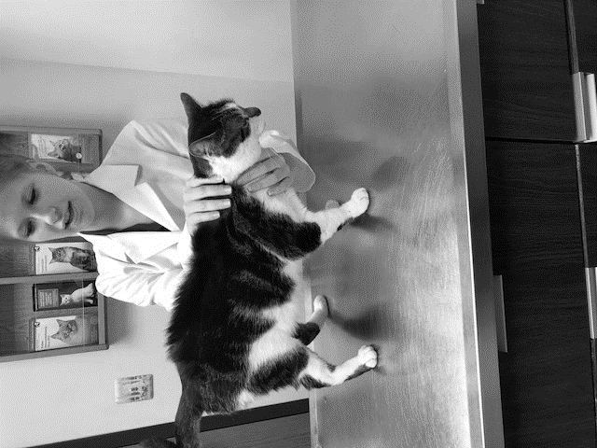

9.3.3. Condition of skin and coat

### Step 4: Examine the mouth

Return your cat to face the judge. Demonstrate opening the cat’s mouth to examine the teeth and gums. Verbally tell the judge what you are looking for such as defects of teeth and pink, moist gums and tongue.

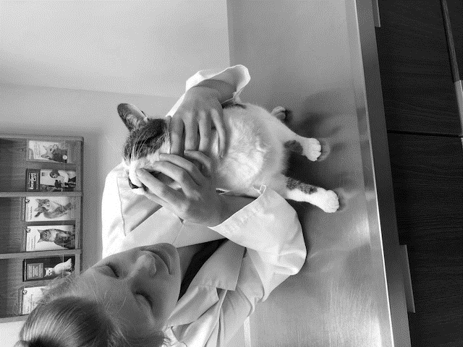

9.3.4. Examination of mouth

### Step 5: Nose

Show the cat’s nose to the judge and explain what you are looking for when examining the nose. There should be no discharge or skin abrasions. It should be clean and free of debris.

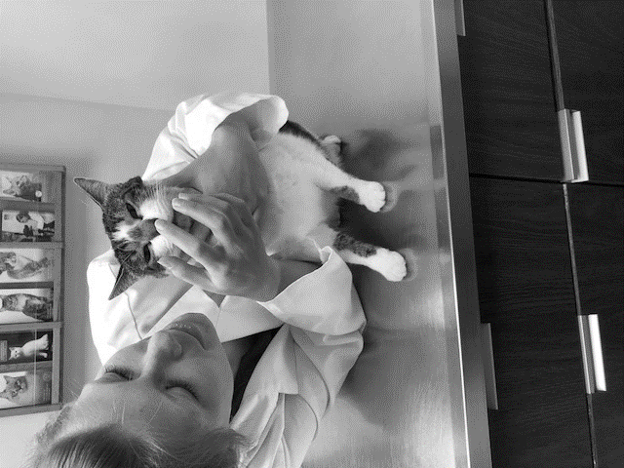

9.3.5. Examination of nose

### Step 6: Eyes and Ears

When showing the eyes to the judge open each eye individually to show that there is no discharge, defect or debris present in either eye. Next flip each ear pinna (outer ear) slightly back to look for debris or ectoparasites like ear mites.



9.3.6. Examination of eyes and ears

### Step 7: Legs, Paws and Claws

Run your hand down each leg, starting with the front legs, to show there are no concerns with legs and press gently to expose the nails (should be freshly trimmed) on the paws.



9.3.7. Examination of legs, paws and claws

### Step 8: Undercarriage

Stand your cat up on its rear legs by lifting the front legs off the table to expose the underside of your cat to the judge to examine the coat on the underside, noting there is no hair loss and coat is clean.



9.3.8. Undercarriage

### Step 9: Final pose

Place your cat back facing the judge in the sitting (or laying) position with its tail wrapped to the side and wait for the judge to ask any questions and release you from judging. Once released, pick your cat back up in the safety carry and return your cat to its carrier.

# Other fun cat facts!

* A group of cats are called a clowder.
* Cats have 20 tiny muscles in the face, head and neck that control the movement of their ears.
* The gestation (pregnancy) of a cat is approximately nine weeks.
* Cats purr for many reasons, including, happiness, contentment, nervousness and self-comfort.
* The scientific term for “hairball” is bezoar.
* A polydactyl has additional toes! They can be present on either the front feet, rear feet or both. They are also known as “Hemingway Polydactyl” as the author Hemingway was fond of these cats.
* A cat can jump up to six times it’s body length.
* Cats use their whiskers to detect whether or not that can fit through a space.
* A cat’s nose has unique ridges that are as different as the human fingerprint.
* Cats are the most popular pet in the United States.
* The average resting heart rate of the cat is 120-140 and will increase to the upper end of 220 with stress.
* The normal body temperature of a cat is 100.0-102.5 F.
* The average litter of kittens is 3-5.
* Female cats can become pregnant by more than one male at the same time (hello colorful litters!)
* While some sleep more than others, we can all agree cats sleep most of their life.
* Unsterilized male cats are called Toms while unsterilized females are called Queens.
* The average age for domestic cats reaches well into the late teens (15-17 years old).
* While grooming is sometimes necessary, bathing is not usually necessary as cats clean themselves regularly. Much of their time not spent sleeping or eating is spent on keeping their coats spic n’ span.
* Tri- colored cats (such as calicoes and tortoiseshell/torties) are almost always female. If they are male, it’s a genetic anomaly that happens very rarely. These colorful male cats are sterile and may have other health issues.

# 

# Other Resources

* American Association of Feline Practitioners Community Page
  + [www.catfriendly.com](http://www.catfriendly.com/)
* Cornell University- Feline Health Center
  + [www.vet.cornell.edu](http://www.vet.cornell.edu/)
* UC Davis Veterinary Medicine- Cats
  + [www.vetmed.ucdavis.edu](http://www.vetmed.ucdavis.edu/)
* Washtenaw County 4-H Youth Show Project Guides, Record Books and Project Forms
  + https://www.canr.msu.edu/washtenaw/washtenaw_county_4_h/youthshow